Pizza Chatbot

Steps to access the chatbot

Step 1: Create a data base for pizza

I have used 3 tables for storing User details, Pizza details, Status details

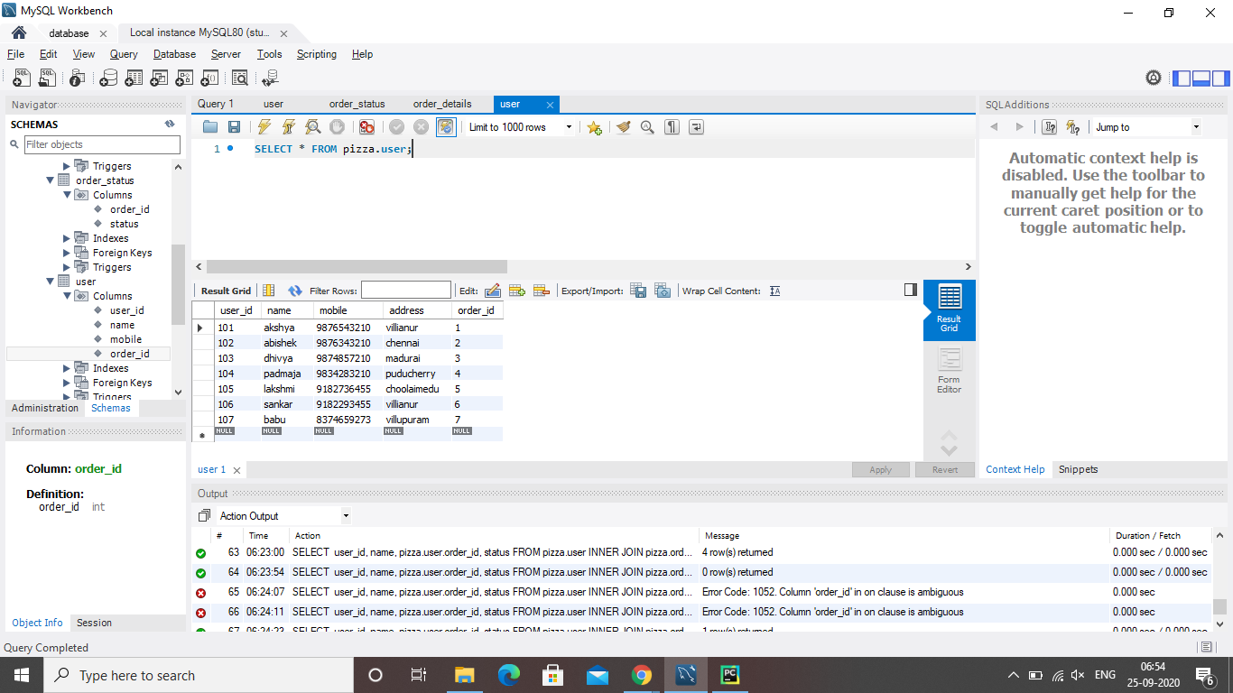

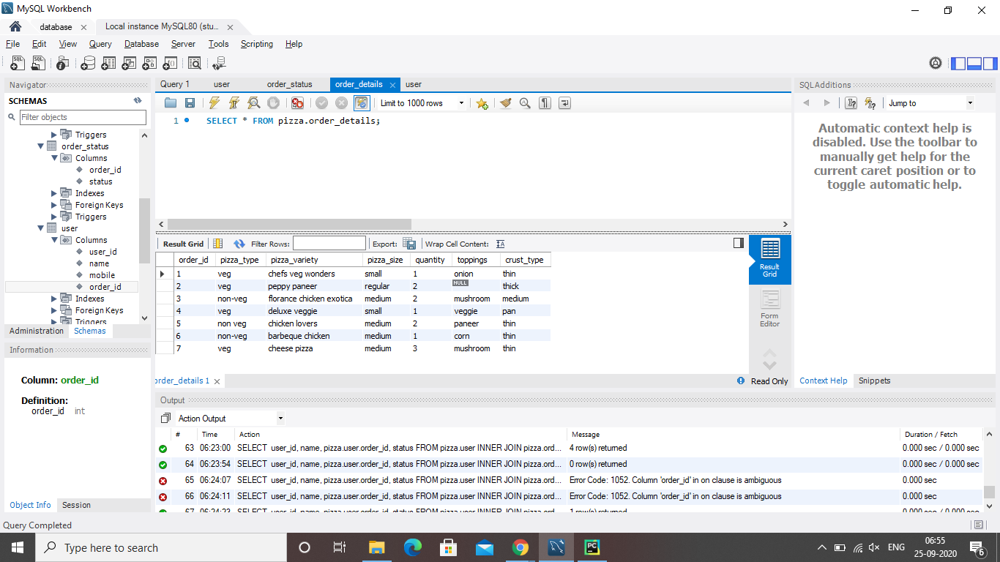

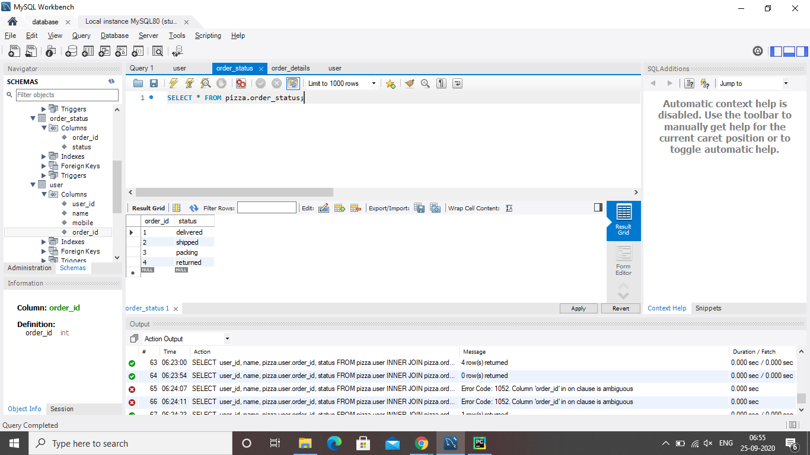

Step 2: Download the repository and run the pizza.py file.

Step 3: Construct the chat flow for your bot and train using dialogflow

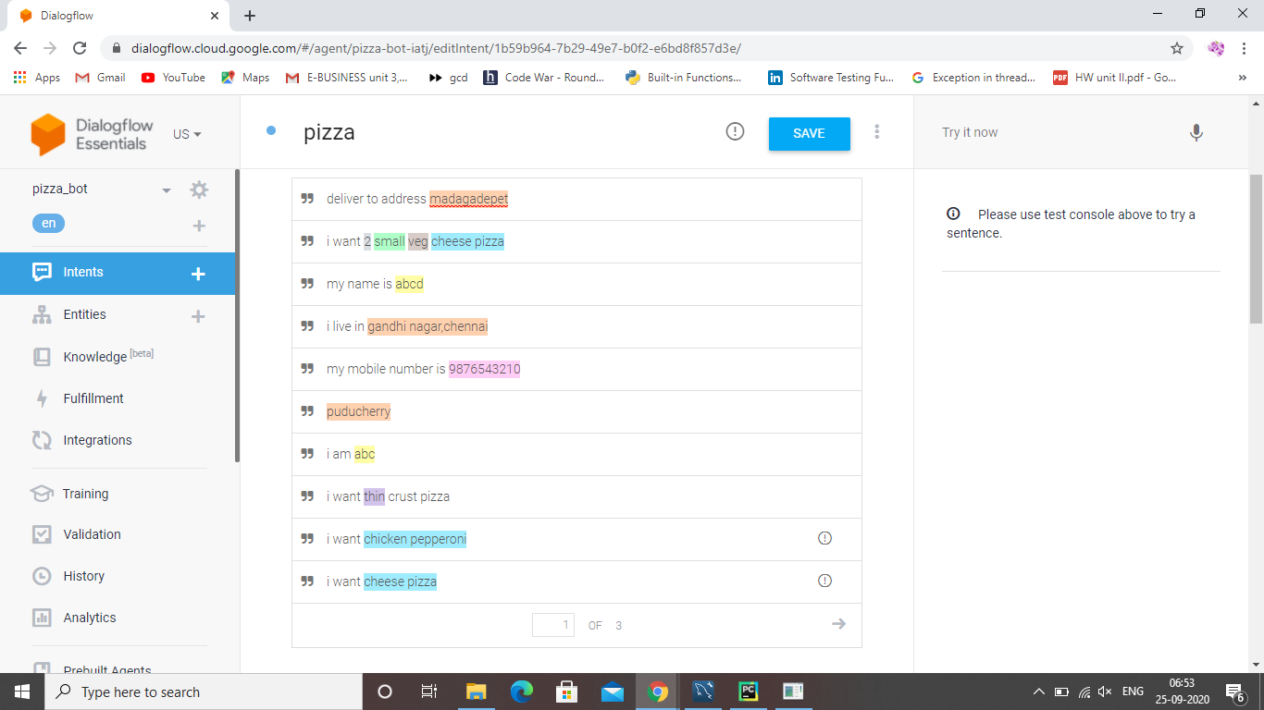

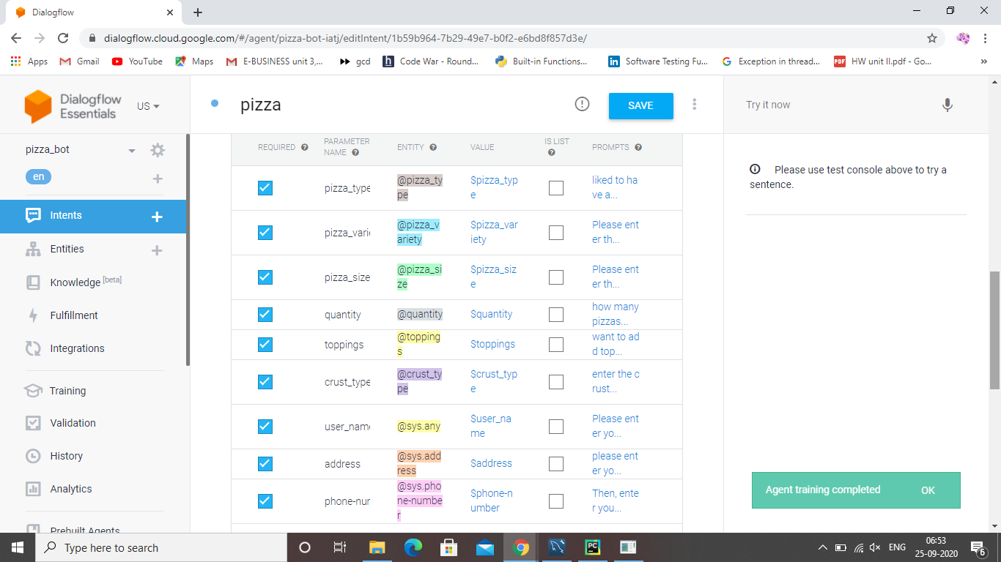

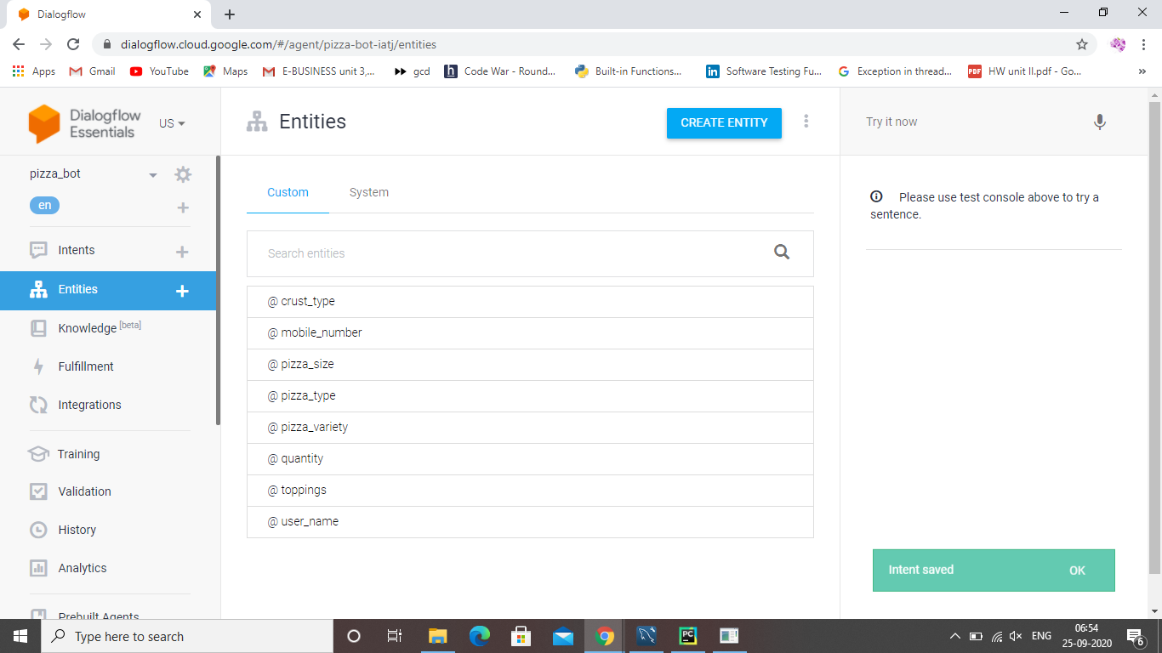

Step 4: download ngrok tool which is used to create the webhook link

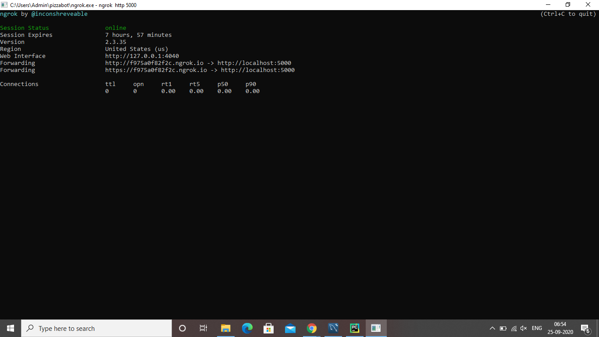

Step 5: Fill the webhook link in fulfillment of dialogflow.

Now your bot is linked with database and ready to use.

Step 6: integrate your bot in an app or web to use.

